**JOBSHEET 2**

**Bubble Sort**

**LATIHAN 01**

package BubbleShort;

public class Latihan01 {

public static void main(String[] args) {

int[] data = new int[] { 2, -8, 42, 12, -10};

int i, step, temp, n = data.length;

System.out.println("Sebelum Di Urutkan: ");

for (i=0; i < data.length; i++) {

System.out.print(data[i] + "" + ",");

}

System.out.println("");

for(step = 1; step < n; step++)

{

for(i = 0; i < n-step; i++)

{

if(data[i] > data[i+1])

{

temp = data[i];

data[i] = data[i+1];

data[i+1] = temp;

}

}

System.out.print("Step " + step + ": ");

for (i=0; i < data.length; i++)

{

System.out.print(data[i] +" ");

}

System.out.println("");

}

System.out.println("Setelah Di Urutkan: ");

for (i=0; i < data.length; i++) {

System.out.print(data[i] +" ");

}

}

}

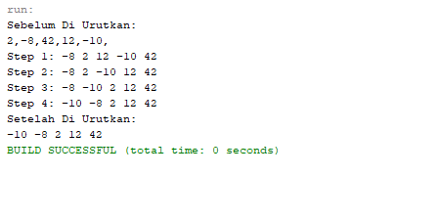

**LATIHAN 02**

package BubbleShort;

public class Latihan02 {

public static void main(String[] args) {

int[] data = new int[] { 2, -8, 42, 12, -10};

int i, step, temp, n = data.length;

System.out.println("Sebelum Di Urutkan: ");

for (i=0; i < data.length; i++) {

System.out.print(data[i] + "" + ",");

}

System.out.println("");

for(step = 1; step < n; step++)

{

for(i = 0; i < n-step; i++)

{

if(data[i] < data[i+1])

{

temp = data[i];

data[i] = data[i+1];

data[i+1] = temp;

}

}

System.out.print("Step " + step + ": ");

for (i=0; i < data.length; i++)

{

System.out.print(data[i] +" ");

}

System.out.println("");

}

System.out.println("Setelah Di Urutkan: ");

for (i=0; i < data.length; i++) {

System.out.print(data[i] +" ");

}

}

}

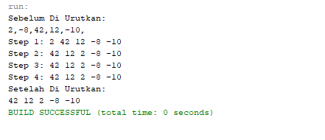

**LATIHAN 03**

package BubbleShort;

public class Latihan03 {

public static void main(String[] args) {

int[] data = new int[] { 2, -8, 42, 12, -10 };

int i, step, temp, n = data.length;

int swap;

System.out.println("Sebelum Di Urutkan: ");

for (i=0; i < data.length; i++) {

System.out.print(data[i] + "" + ",");

}

System.out.println("");

for(step = 1; step < n; step++)

{

swap = 0;

for(i = 0; i < n-step; i++)

{

if(data[i] > data[i+1])

{

temp = data[i];

data[i] = data[i+1];

data[i+1] = temp;

swap = 1;

}

}

if(swap == 0)

{

break;

}

System.out.print("Step " + step + ": ");

for (i=0; i < data.length; i++)

{

System.out.print(data[i] +" ");

}

System.out.println("");

}

System.out.println("Setelah Di Urutkan: ");

for (i=0; i < data.length; i++) {

System.out.print(data[i] +" ");

}

}

}

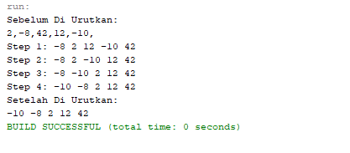

**TUGAS**

package BubbleShort;

import java.util.Scanner;

public class Tugas {

public static void main(String[] args) {

Scanner baca = new Scanner(System.in);

int [] data = new int[10];

{

System.out.println("Program Sorting - Bubble Sort");

}

for(int i = 0; i < data.length; i++){

System.out.print("Masukkan Bilangan ke-" + " " + (i+1)+ " : " );

data [i] = baca.nextInt();

}

System.out.println("");

double jumlah = 0;

double rata;

for(int i=0; i < data.length; i++)

{

jumlah = jumlah + data[i];

}

rata = jumlah / data.length;

System.out.println("Nilai Rata-rata = " + rata);

int i, step, temp, n = data.length;

int swap;

System.out.println("Data sebelum pengurutan: ");

for (i=0; i < data.length; i++) {

System.out.print(data[i] + "" + ",");

}

System.out.println("");

System.out.println("Proses Pengurutan...");

for(step = 1; step < n; step++){

swap = 0;

for(i = 0; i < n-step; i++){

if(data[i] > data[i+1]){

temp = data[i];

data[i] = data[i+1];

data[i+1] = temp;

swap = 1;

}

}

if(swap == 0) {

break;

}

System.out.print("Step " + step + " : ");

for (i=0; i < data.length; i++){

System.out.print(data[i] +" ");

}

System.out.println("");

}

System.out.println("Data setelah pengurutan Ascending: ");

for (i=0; i < data.length; i++) {

System.out.print(data[i] +" ");

}

System.out.println("");

System.out.println("Bilangan Terbesar :" + data[9]);

System.out.println("Bilangan Terkecil :" + data[0]);

}

}

